JENKINS TASK – 1

Launch jenkins and explore creating projects and users.

Launched jenkin in the browser - http://localhost:8080

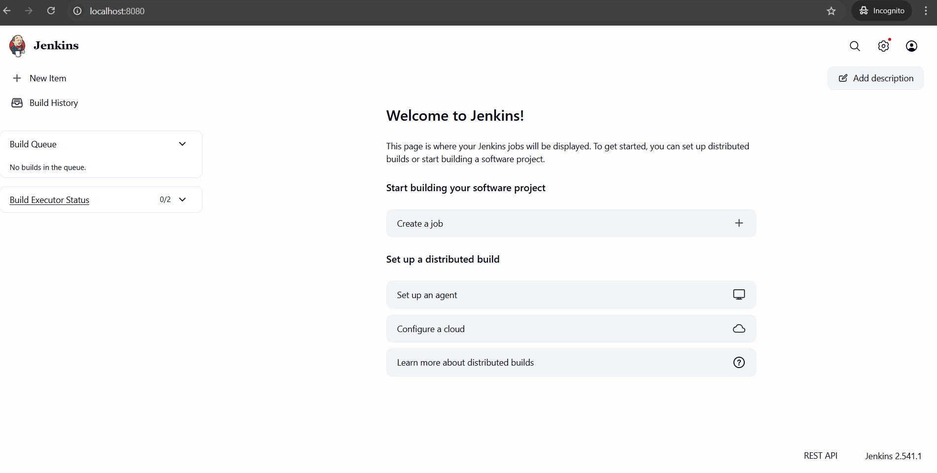

Created new Project in Jenkin and build it.

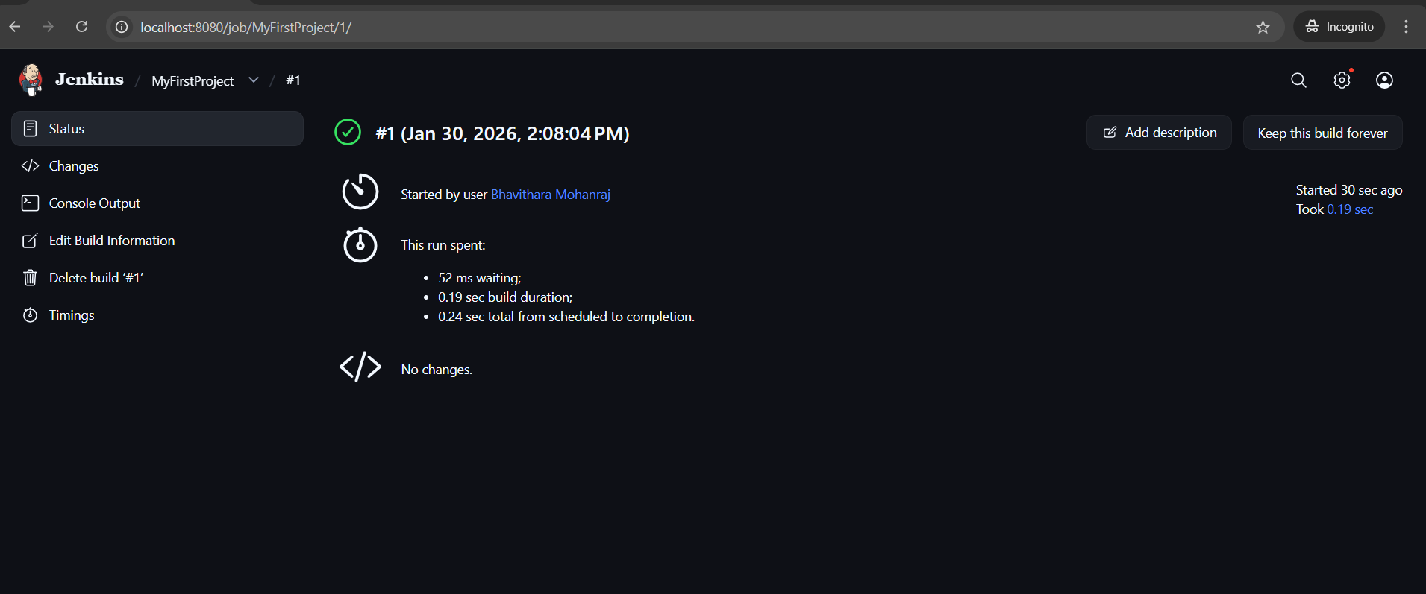

Created additional new user in jenkin

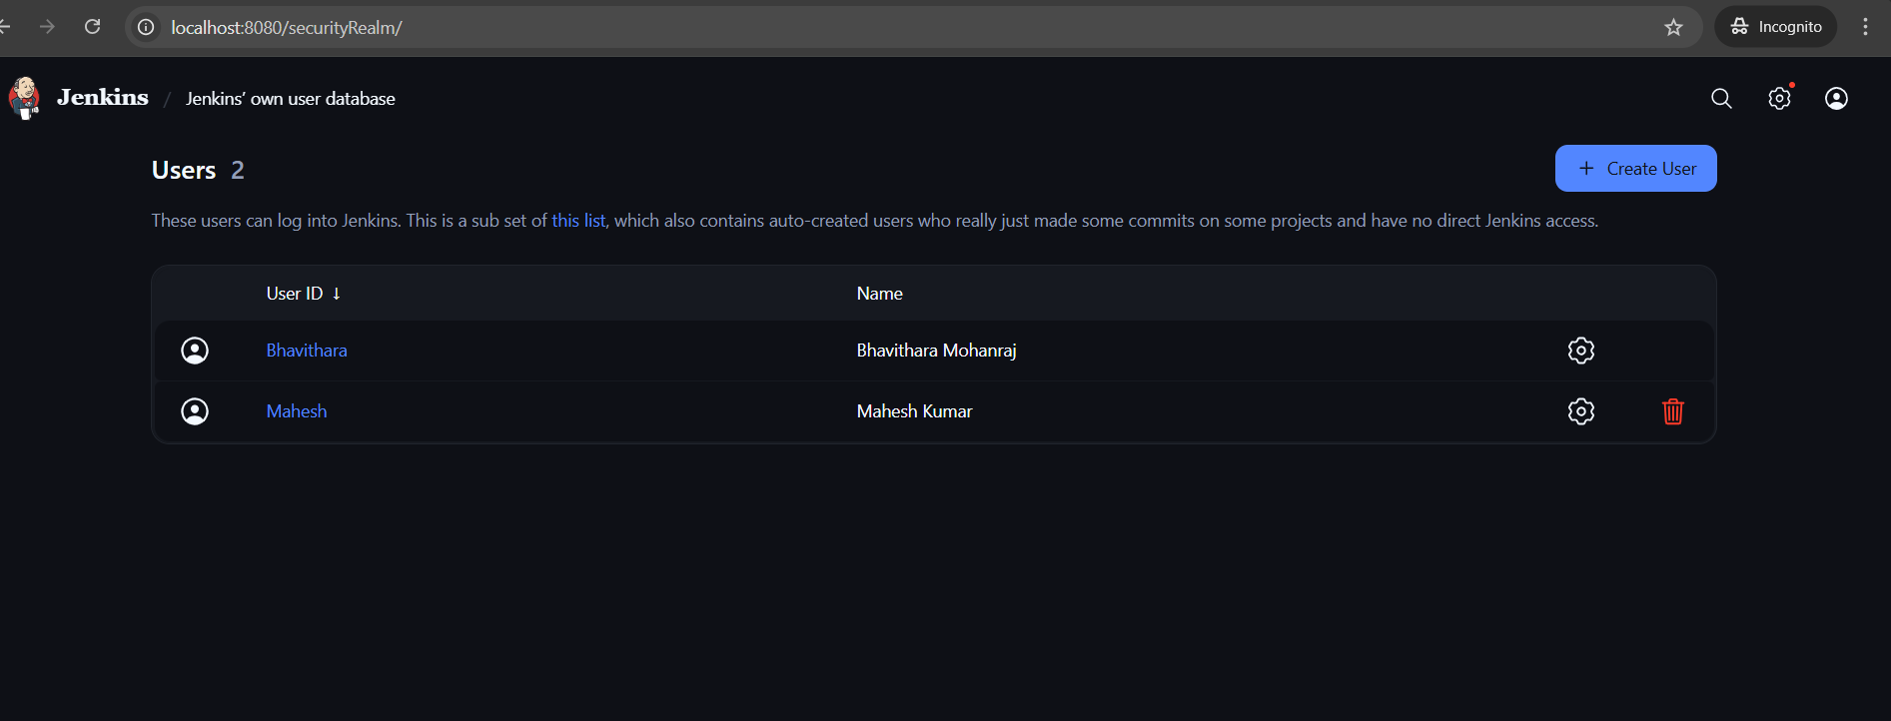

Explored Plugins option in Jenkin

